DATE: 31.08.2018
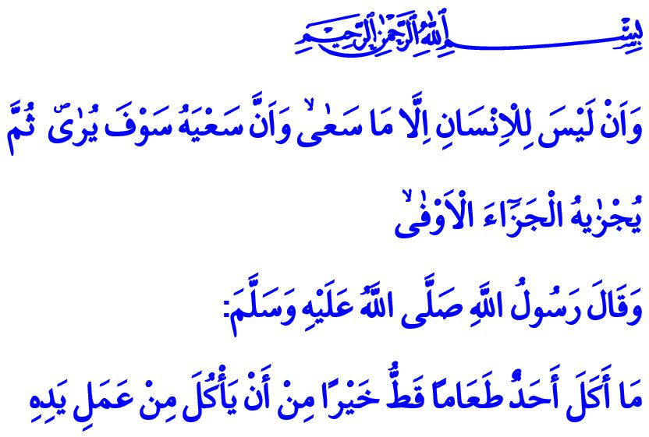
WORKING ENRICHES OUR LIVES
Honorable Brothers and Sisters!
In the verse I have recited, our Almighty Lord (swt) states: “And that there is not for man except that [good] for which he strives. And that his effort is going to be seen. Then he will be recompensed for it with the fullest recompense.”
The Beloved Prophet (saw) says in the hadith I have read: “Nobody has ever eaten a better meal than that which one has earned by working with one’s own hands.”
Dear Believers!
Our Lord, who is al-Razzaq (The Provider and Sustainer), is the One Who bestows upon us every sip we drink, every morsel we eat, the air we breathe, the bread, and the water. He is the Owner of eternal offerings. We know and believe while saying “O Razzaq!” that Allah is the One Who gives the nourishment of both our souls and our bodies, and He is the Guarantor of our sustenance. What is incumbent upon us as believers is to work in lawful ways to obtain sustenance, to pursue the income that is clean and decent. Our beloved Prophet (saw) expressed this point as follows: “No soul will die until it has received all its provision decreed by Allah (swt). So, fear Allah and seek your provision from the convenient ways. Take that which is halal (permissible) and leave that which is haram (forbidden).”
Brothers and Sisters!
The prophets who were sent as guides to mankind were also engaged in various professions such as tailoring, carpentry, farming, or trade, and provided halal sustenance for themselves and their families without being a burden on anybody. It is the Sunnah of the prophets to work with elbow grease and hand labor, to be in struggle for the halal gain, to produce and spend lawfully.
Allah the Almighty (swt) makes the following call to all mankind in the Holy Qur’an:

“O mankind, eat from whatever is on earth [that is] lawful and good...”
Esteemed Muslims!
Working brings peace and blessings to our life. Honorable for servants is to work in jobs that will be approved by Allah (swt), using the mind, body, and the heart bestowed by Him (swt). Believers, then, should always renew themselves, knowing that they shall be in loss if “two of their days are equal”.
Our religion prohibits laziness, irresponsibility, and any act of fraud and dishonesty with the purpose of acquiring unearned gains. It does not in any manner allow any means to acquire unearned gains such as bribery, usury, hoarding, and black-marketing, which disrupt the safe and peaceful environment of the society by disregarding its moral values. As a matter of fact, our Prophet (saw) states, “It is better for anyone of you to take a rope and cut the wood (from the forest) and carry it over his back and sell it (as a means of earning his living) rather than to ask a person for something and that person may give him or not.”.
Dear Brothers and Sisters!
In the Holy Qur’an Allah (swt) commands, “But seek, through that which Allah has given you, the home of the Hereafter; and [yet], do not forget your share of the world…”. Muslims should take this divine warning into consideration and not forsake their life in the Hereafter for the worldly life, or vice versa. They should maintain such virtues as honesty, justice, and fairness in business life, and not lose the consciousness of servitude to Allah (swt) while working to maintain their life.
I would like to conclude my khutbah with the following verse describing the believers: “[They are] men whom neither commerce nor sale distracts from the remembrance of Allah and performance of prayer and giving of zakah. They fear a Day in which the hearts and eyes will [fearfully] turn about.”

Najm, 53/39-41.
Bukhari, Buyu, 15.
Ibn Majah, Tijarat (Business Transactions), 2.
Baqarah, 2/168.
Bukhari, Zakat, 50.
Qasas, 28/77.
Nur, 24/37. General Directorate of Religious Services

